**Different types of charts and their uses:**

1. **Line Graphs**

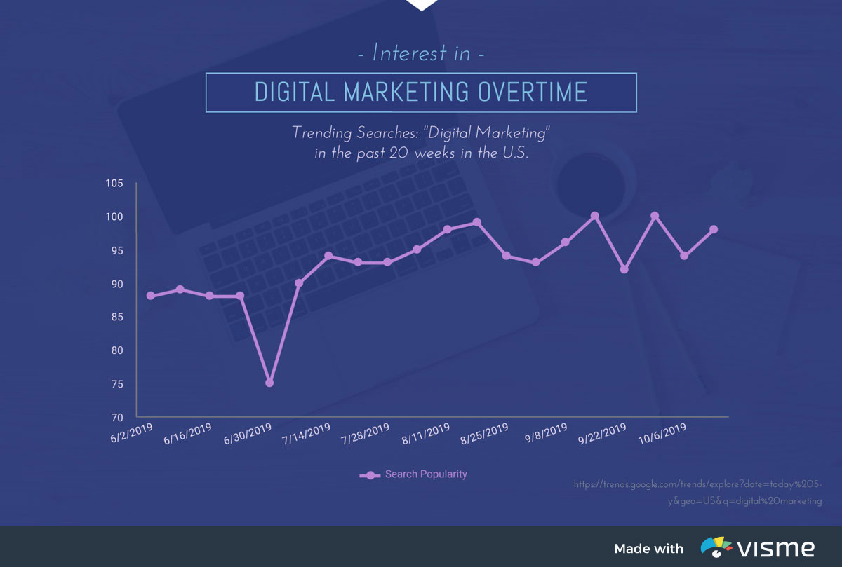

Line charts, or line graphs, are powerful visual tools that illustrate trends in data over a period of time or a particular correlation. For example, one axis of the graph might represent a variable value, while the other axis often displays a timeline.

Each value is plotted on the chart, then the points are connected to display a trend over the compared time span. Multiple trends can be compared by plotting lines of various colours.

For example, the interest of digital marketing over time can be visually shown with ease through the use of a line graph. Simply plot each number of searches along the timeline to view the trend.

1. **Bar Graphs**

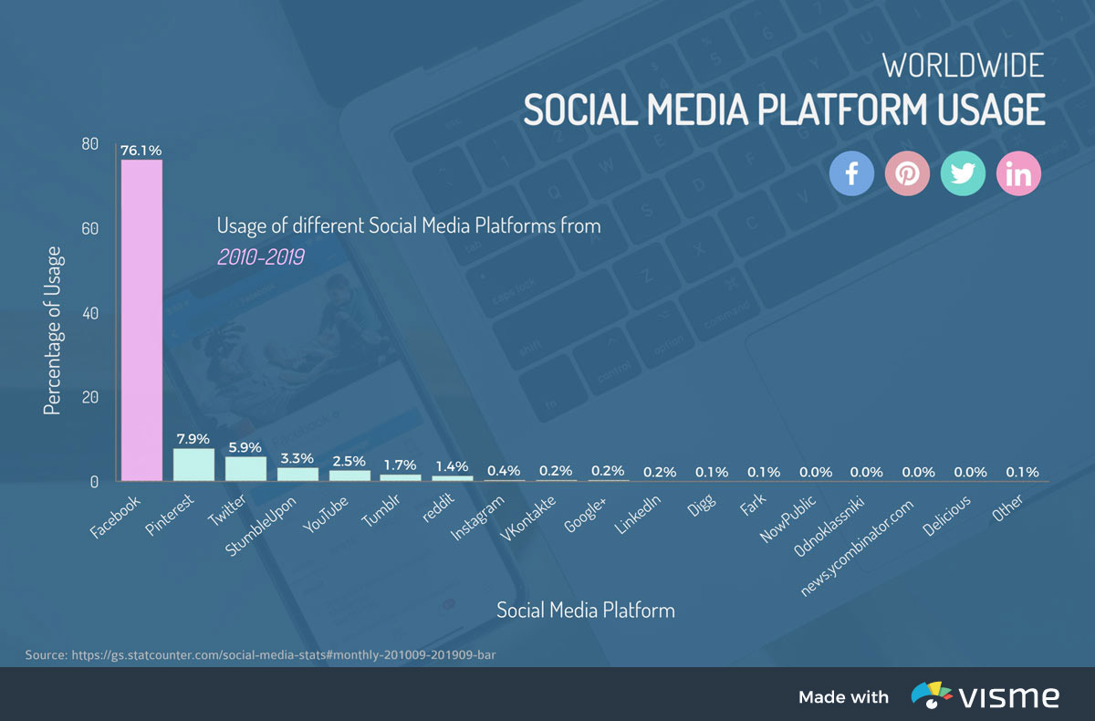

The simplest and most straightforward way to compare various categories is the classic bar graph. The universally-recognized graph features a series of bars of varying lengths.

One axis of a bar graph features the categories being compared, while the other axis represents the value of each. The length of each bar is proportionate to the numerical value or percentage that it represents.

For example, $4 could be represented by a rectangular bar four units long, while $5 would equate to a five-unit long bar. With one quick glance, audiences learn exactly how the various items size up against one another.

Bar graphs work great for visually presenting nearly any type of data, but they hold particular power in the marketing industry. The graphs are ideal for comparing any sort of numeric value, including group sizes, inventories, ratings and survey responses.

1. **Pie Charts**

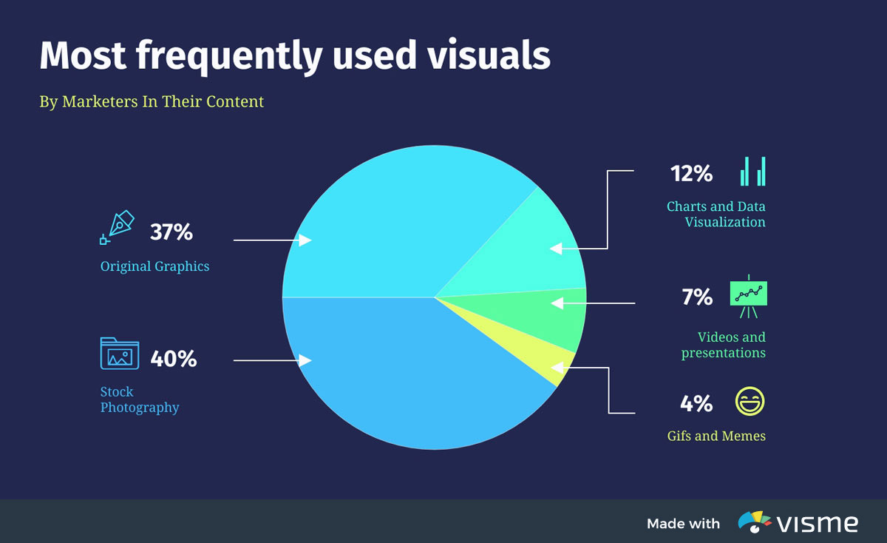

Pie charts are the simplest and most efficient visual tool for comparing parts of a whole. For example, a pie chart can quickly and effectively compare various budget allocations, population segments or market-research question responses.

Marketing content designers frequently rely on pie charts to compare the size of market segments. For example, a simple pie graph can clearly illustrate how the most popular mobile-phone manufacturers compare based on the sizes of their user-bases.

Audiences are able to quickly understand that stock photography is the most-used visual in marketing, with original graphics – like those that can be [created with Visme](https://www.visme.co/social-media-graphics/) – coming in as a close second.

1. **Histograms:**

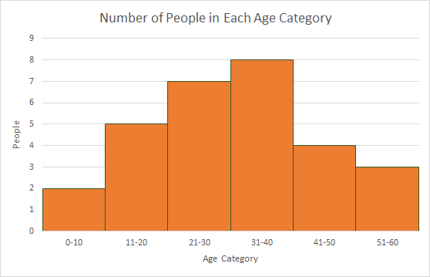A **histogram** is a specific type of bar chart, where the categories are ranges of numbers. Histograms therefore show combined continuous data.

1. **Spider Charts**

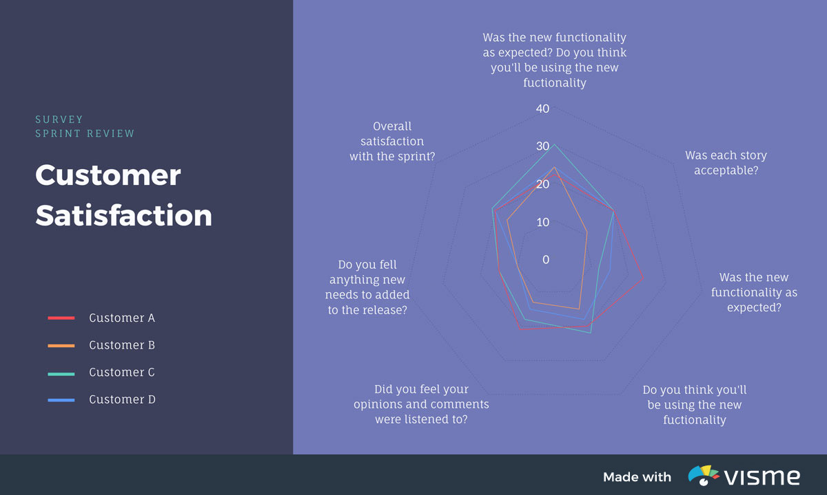

When a statistician needs to visually compare three or more quantitative variables, he or she might choose to use a [radar chart](https://visme.co/blog/types-of-charts/), also known as a spider or star chart.

The chart usually consists of a series of radii, each representing a different category, that splay out from a center point like spokes.

The length of each “spoke” is proportionate to the value being compared. For each category, the spokes are then connected with a line of a designated pattern or color, forming a star-like shape with points equal to the number of categories.

The result is a graphic representation that can reveal trends and compare categories all at the same time.

1. **Gantt Charts**

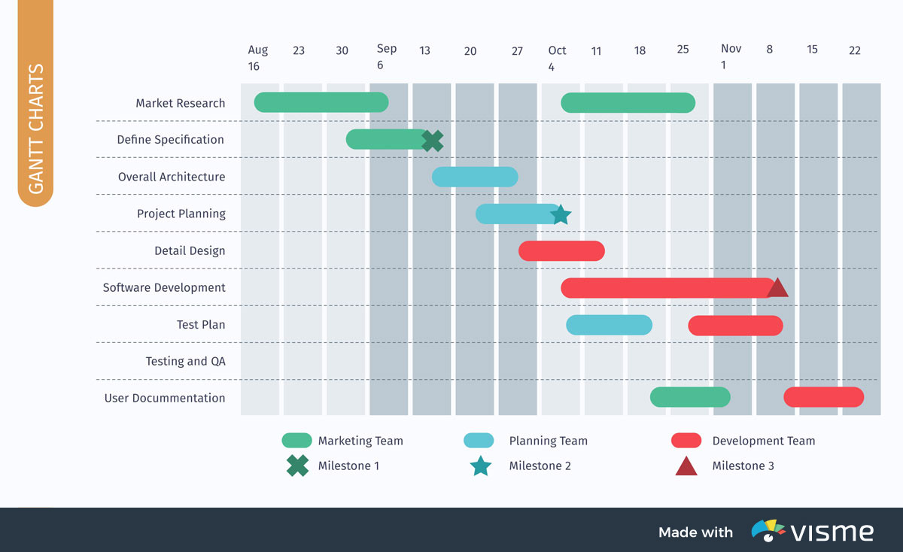

Gantt charts are special types of bar graphs used to diagram projects and schedules. The use of colored bars of varying lengths reflect not only a project’s start and end dates, but also important events, tasks, milestones and their timeframes.

Modern Gantt charts can also illustrate activities’ dependency relationships.

If Team 3’s completion of task C, for example, is dependent upon the prior completion of task B by Team 2, the chart can not only reflect that relationship, but the scheduled dates and deadlines for each.

1. **Control Charts**

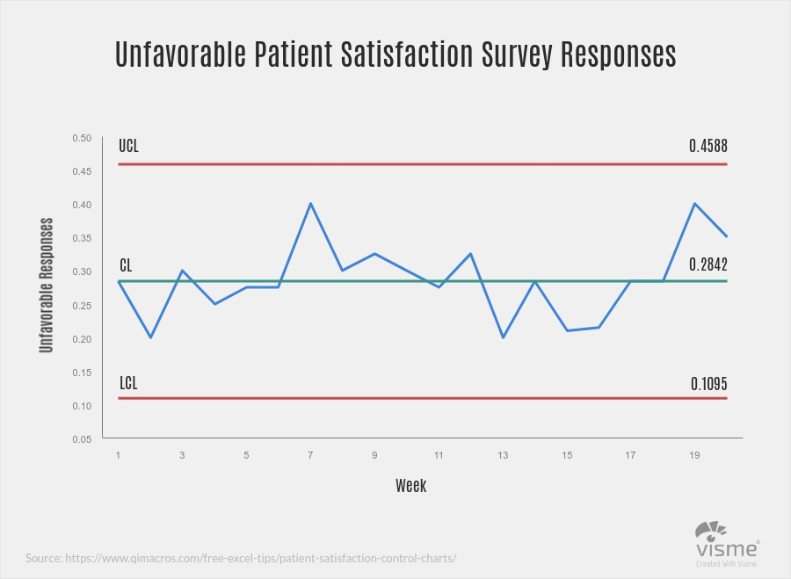

Also commonly known as a process-behaviour chart, a control chart helps determine if a data set falls within a mean or predetermined control range.

Frequently used in quality control processes, a typical control chart consists of points plotted on two axes, representing sample measurements.

The mean of each point is calculated, and a centre line across the graph at the mean value. Then, a standard deviation from the mean is calculated using each sample.

Finally, upper and lower control limits are determined and diagrammed to reflect the points at which deviation is beyond the expected standard.

1. **Scatter Plots**

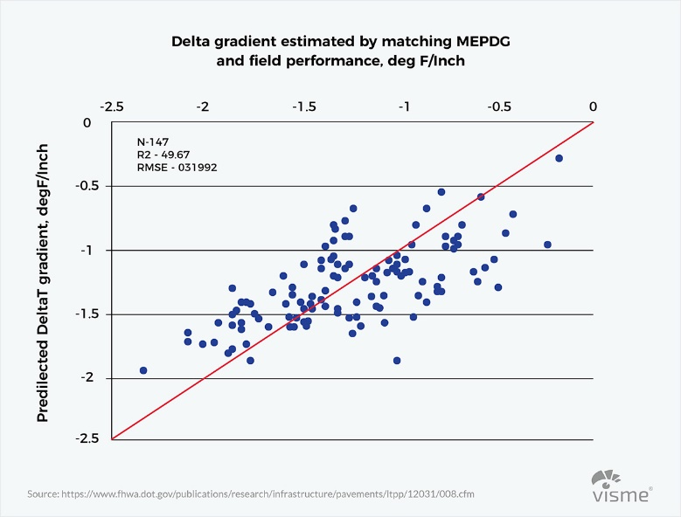

Scattergrams, also known as scatter plots, are graphs that show the relationship between two or more variables. The plots use mathematical coordinates to represent two variables of a data set.

Data is displayed in a scattergram as a collection of points, each representing the value variables plotted on a horizontal and vertical axes. If points are color-coded, an additional variable can be represented in a single chart.

By plotting certain data sets, scientists can discover trends of which they might not otherwise be aware. For example, a scattergram might allow a doctor to plot patients’ resting heart rates against their body-mass index figures.

The resulting graph reveals that a higher heart rate correlates with a higher BMI.

1. **Trellis Plots**

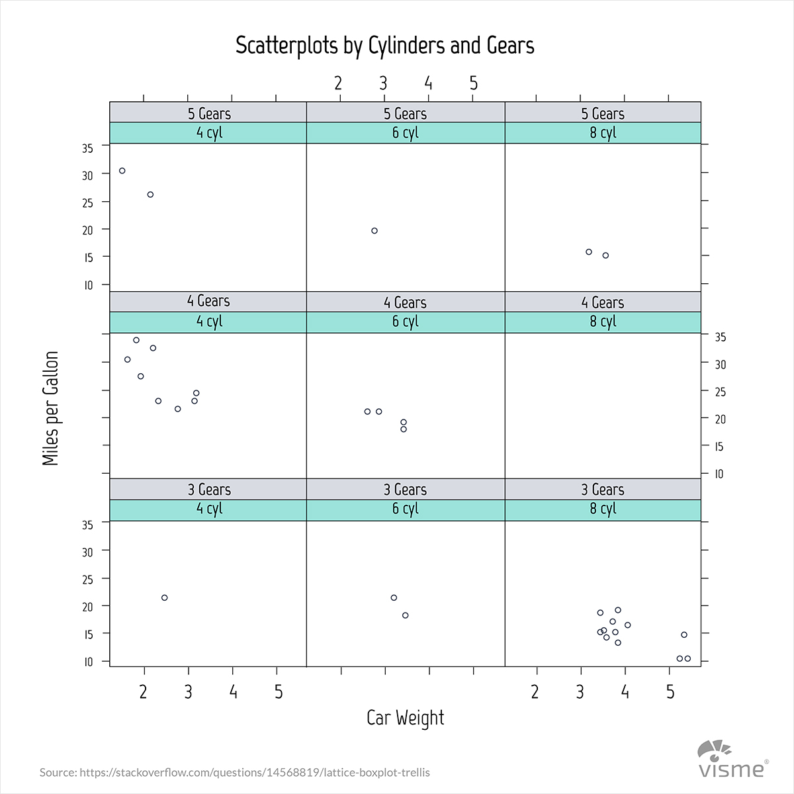

Sometimes a statistician will need to compare more data sets than can be represented by a single graph. What if, for example, a graph needs to compare not only miles driven and gallons used, but also the number of gears and cylinders contained in each vehicle sample?

A trellis plot, also called a lattice graph or plot, can display and compare all of those variables. While the above example uses a series of scatter charts, trellis plots commonly feature series of bar or line graphs, as well.

1. **Function Plots**

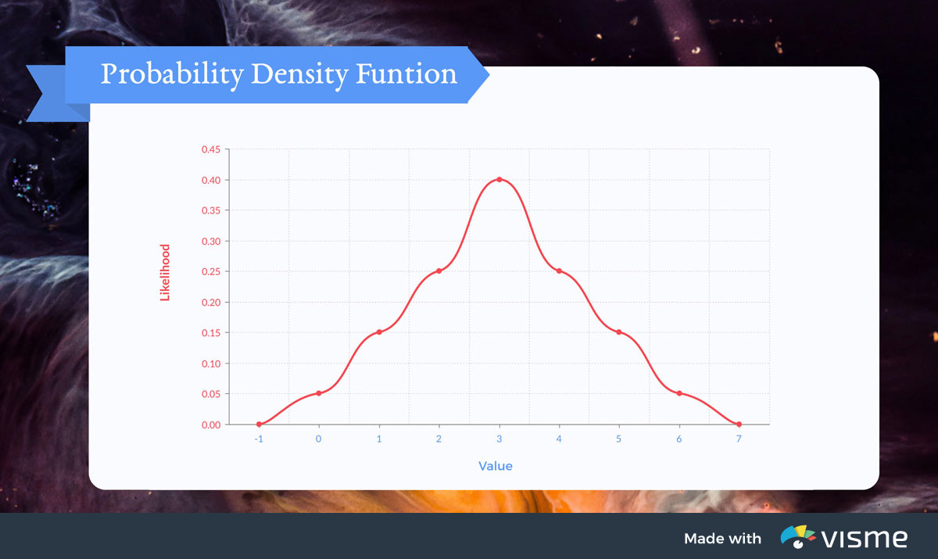

Mathematicians, engineers and statisticians often need to determine the value of an equation by graphing its result. The graph of a function is the set of all points whose coordinates satisfy the equation.

Therefore, the function of an equation with variables of ***x*** and ***y*** would be drawn on a graph with an *x* and *y* axis. Likewise, an equation that also included a variable of *z* would need to be drawn on a three-dimensional graph with a third axis.

Function graphs of common shapes are visually associated with their corresponding algebraic formulas.

### 11. Stacked Area Charts

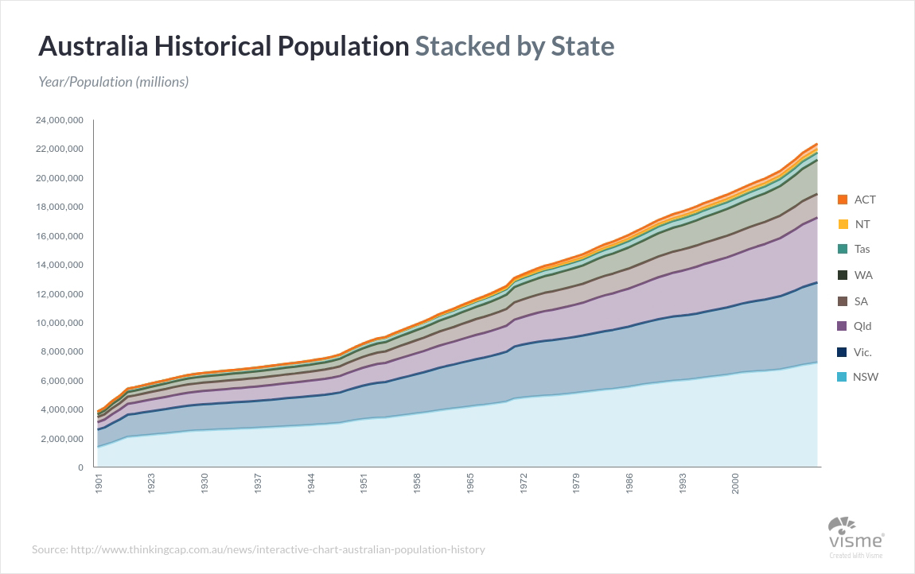

[Stacked area charts](https://visme.co/blog/types-of-charts/) are frequently used to diagram changes of multiple variables across time. Multiple lines can be drawn, for example, to track the population changes of various states across time.

The area below each line can be colored a different hue to represent the state it signifies, resulting in a graph that clearly represents population trends, while at the same time displaying each state’s data in order from least to most populous.

### 12. Stacked Bar Graphs

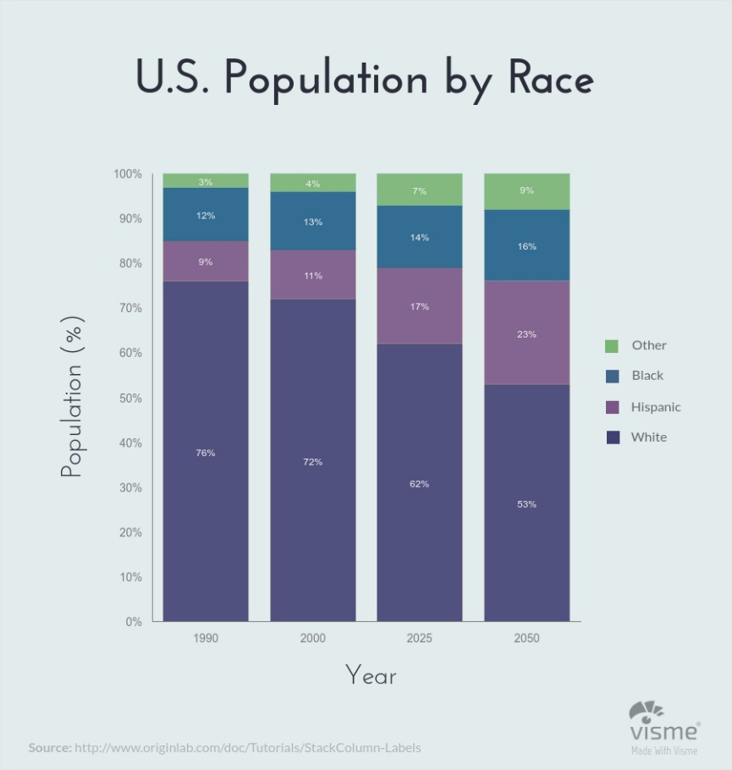

When studying groups of people, it’s common to compare multiple variables at once. After all, it’s enormously more useful to examine racial backgrounds, ages and gender in addition to total population.

A stacked bar graph combines elements of the traditional bar graph and the pie graph to communicate totals, trends and proportions in a single illustration.

Rather than simply illustrating changes in global population over time with a traditional column bar graph, a stacked bar graph can also represent the racial makeup of the population during each year and how those proportions have changed during the same period.

**13. Stacked Area Charts**

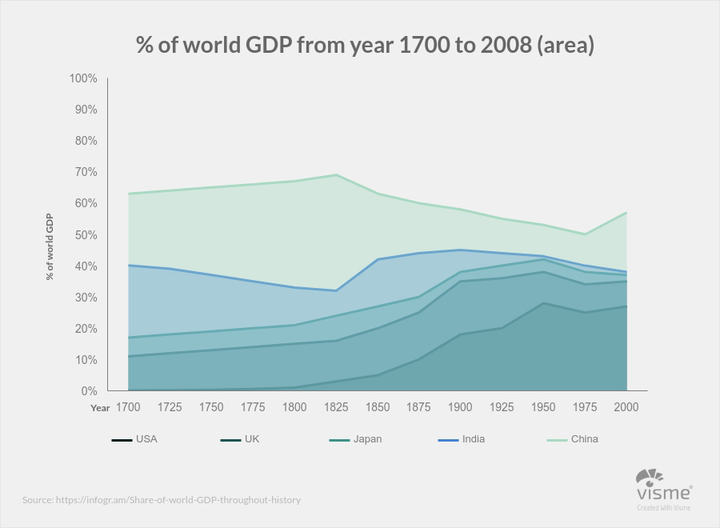

Stacked area charts are ideal for comparing values that would normally require multiple line graphs. Each line represents a different category, and the area below each line is generally shaded a designated color so each data set can be easily compared.

For example, an area chart with one axis that represents a numeric value, and another axis that serves as a timeline, data for various categories over time can be tracked and compared with a single graphic.

**14. Bubble Chart**

Bubble charts are super useful types of graphs for making a comparison of the relationships between data in 3 numeric-data dimensions: the Y-axis data, the X-axis data, and data depicting the bubble size.

Bubble charts are very similar to XY Scatter plots but the bubble chart adds more functionality – a third dimension of data that can be extremely valuable.

Both axes (X and Y) of a bubble chart are numeric.

Bubble Chart Uses:

* When you have to display **three or four dimensions** of data.
* When you want to compare and **display the relationships** between categorized circles, by the use of proportions.

Example:

The bubble chart below shows the relationship between Cost (X-Axis), Profit (Y-Axis), and Probability of Success (%) (Bubble Size).

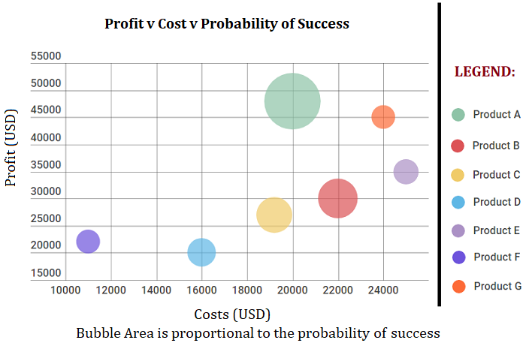

**15. Spline Chart**

The Spline Chart is one of the most widespread types of graphs and charts used in statistics. It is a form of the line chart that represent smooth curves through the different data points.

Spline charts possess all the characteristics of a line chart except that spline charts have a fitted curved line to join the data points. In comparison, line charts connect data points with straight lines.

Spline Chart Uses:

* When you want to plot data that requires the usage of curve-fitting such as **a product lifecycle chart** or an impulse-response chart.
* Spline charts are often used in **designing Pareto charts**.
* Spline chart also is often used **for data modeling** by when you have limited number of data points and estimating the intervening values.

Example:

The following spline chart example shows sales of a company through several months of a year:

